SEC Form 3
FORM 3 | UNITED STATES SECURITIES AND EXCHANGE COMMISSION  Washington, D.C. 20549  INITIAL STATEMENT OF BENEFICIAL OWNERSHIP OF SECURITIES  Filed pursuant to Section 16(a) of the Securities Exchange Act of 1934  or Section 30(h) of the Investment Company Act of 1940
  OMB APPROVAL
  OMB Number: | 3235-0104
  Estimated average burden
  hours per response: | 0.5
1. Name and Address of Reporting Person*  (Street) | 2. Date of Event Requiring Statement (Month/Day/Year)  08/31/2026 | 3. Issuer Name and Ticker or Trading Symbol  Zoom Communications, Inc. [ ZM ]  Foreign Trading Symbol
  Epstein Jeff
  (Last) | (First) | (Middle)
  C/O ZOOM COMMUNICATIONS, INC.
  55 ALMADEN BLVD, 6TH FLOOR
  SAN JOSE | CA | 95113
  (City) | (State) | (Zip)
 |  | 4. Relationship of Reporting Person(s) to Issuer  (Check all applicable) | 5. If Amendment, Date of Original Filed (Month/Day/Year)
   | Director |  | 10% Owner
   | Officer (give title below) |  | Other (specify below)
6. Individual or Joint/Group Filing (Check Applicable Line)
Form filed by One Reporting Person
Form filed by More than One Reporting Person

Table I - Non-Derivative Securities Beneficially Owned
1. Title of Security (Instr. 4) | 2. Amount of Securities Beneficially Owned (Instr. 4) | 3. Ownership Form: Direct (D) or Indirect (I) (Instr. 5) | 4. Nature of Indirect Beneficial Ownership (Instr. 5)
Table II - Derivative Securities Beneficially Owned
(e.g., puts, calls, warrants, options, convertible securities)
1. Title of Derivative Security (Instr. 4) | 2. Date Exercisable and Expiration Date (Month/Day/Year) |  | 3. Title and Amount of Securities Underlying Derivative Security (Instr. 4) |  | 4. Conversion or Exercise Price of Derivative Security | 5. Ownership Form: Direct (D) or Indirect (I) (Instr. 5) | 6. Nature of Indirect Beneficial Ownership (Instr. 5)
1. Title of Derivative Security (Instr. 4) | Date Exercisable | Expiration Date | Title | Amount or Number of Shares | 4. Conversion or Exercise Price of Derivative Security | 5. Ownership Form: Direct (D) or Indirect (I) (Instr. 5) | 6. Nature of Indirect Beneficial Ownership (Instr. 5)
Explanation of Responses:
Remarks:
No securities are beneficially owned.
 | /s/ Cheree McAlpine, Attorney-in-Fact | 09/02/2026
 | ** Signature of Reporting Person | Date
Reminder: Report on a separate line for each class of securities beneficially owned directly or indirectly.
* If the form is filed by more than one reporting person, see Instruction 5 (b)(v).
** Intentional misstatements or omissions of facts constitute Federal Criminal Violations See 18 U.S.C. 1001 and 15 U.S.C. 78ff(a).
Note: File three copies of this Form, one of which must be manually signed. If space is insufficient, see Instruction 6 for procedure.
Persons who respond to the collection of information contained in this form are not required to respond unless the form displays a currently valid OMB Number.
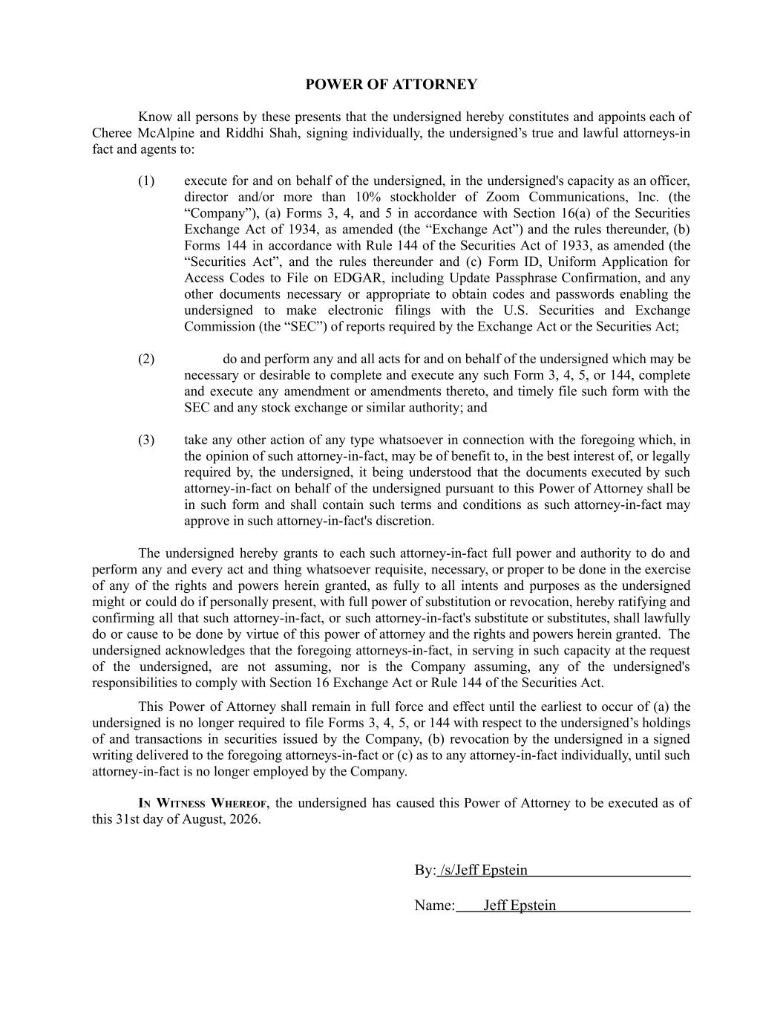
​POWER OF ATTORNEY​ ​Know​​all​​persons​​by​​these​​presents​​that​​the​​undersigned​​hereby​​constitutes​​and​​appoints​​each​​of​ ​Cheree​ ​McAlpine​ ​and​ ​Riddhi​ ​Shah,​ ​signing​​individually,​​the​​undersigned’s​​true​​and​​lawful​​attorneys-in​ ​fact and agents to:​ ​(1)​ ​execute​​for​​and​​on​​behalf​​of​​the​​undersigned,​​in​​the​​undersigned's​​capacity​​as​​an​​officer,​ ​director​ ​and/or​ ​more​ ​than​ ​10%​ ​stockholder​ ​of​ ​Zoom​ ​Communications,​ ​Inc.​ ​(the​ ​“Company”),​ ​(a)​ ​Forms​ ​3,​ ​4,​ ​and​ ​5​ ​in​ ​accordance​ ​with​ ​Section​ ​16(a)​ ​of​ ​the​​Securities​ ​Exchange​ ​Act​ ​of​ ​1934,​ ​as​ ​amended​ ​(the​ ​“Exchange​​Act”)​​and​​the​​rules​​thereunder,​​(b)​ ​Forms​ ​144​ ​in​ ​accordance​​with​​Rule​​144​​of​​the​​Securities​​Act​​of​​1933,​​as​​amended​​(the​ ​“Securities​ ​Act”,​ ​and​ ​the​ ​rules​ ​thereunder​ ​and​ ​(c)​ ​Form​ ​ID,​ ​Uniform​ ​Application​ ​for​ ​Access​ ​Codes​ ​to​ ​File​ ​on​ ​EDGAR,​ ​including​ ​Update​ ​Passphrase​​Confirmation,​​and​​any​ ​other​ ​documents​ ​necessary​ ​or​ ​appropriate​ ​to​ ​obtain​ ​codes​ ​and​ ​passwords​ ​enabling​ ​the​ ​undersigned​ ​to​ ​make​ ​electronic​ ​filings​ ​with​ ​the​ ​U.S.​ ​Securities​ ​and​ ​Exchange​ ​Commission (the “SEC”) of reports required by the Exchange Act or the Securities Act;​ ​(2)​ ​do​​and​​perform​​any​​and​​all​​acts​​for​​and​​on​​behalf​​of​​the​​undersigned​​which​​may​​be​ ​necessary​​or​​desirable​​to​​complete​​and​​execute​​any​​such​​Form​​3,​​4,​​5,​​or​​144,​​complete​ ​and​ ​execute​ ​any​ ​amendment​​or​​amendments​​thereto,​​and​​timely​​file​​such​​form​​with​​the​ ​SEC and any stock exchange or similar authority; and​ ​(3)​ ​take​​any​​other​​action​​of​​any​​type​​whatsoever​​in​​connection​​with​​the​​foregoing​​which,​​in​ ​the​​opinion​​of​​such​​attorney-in-fact,​​may​​be​​of​​benefit​​to,​​in​​the​​best​​interest​​of,​​or​​legally​ ​required​ ​by,​ ​the​ ​undersigned,​ ​it​ ​being​ ​understood​ ​that​ ​the​ ​documents​​executed​​by​​such​ ​attorney-in-fact​​on​​behalf​​of​​the​​undersigned​​pursuant​​to​​this​​Power​​of​​Attorney​​shall​​be​ ​in​ ​such​ ​form​ ​and​ ​shall​ ​contain​ ​such​ ​terms​ ​and​ ​conditions​ ​as​ ​such​​attorney-in-fact​​may​ ​approve in such attorney-in-fact's discretion.​ ​The​ ​undersigned​ ​hereby​ ​grants​ ​to​ ​each​​such​​attorney-in-fact​​full​​power​​and​​authority​​to​​do​​and​ ​perform​​any​​and​​every​​act​​and​​thing​​whatsoever​​requisite,​​necessary,​​or​​proper​​to​​be​​done​​in​​the​​exercise​ ​of​ ​any​ ​of​ ​the​ ​rights​ ​and​ ​powers​ ​herein​ ​granted,​ ​as​ ​fully​ ​to​ ​all​ ​intents​ ​and​ ​purposes​​as​​the​​undersigned​ ​might​​or​​could​​do​​if​​personally​​present,​​with​​full​​power​​of​​substitution​​or​​revocation,​​hereby​​ratifying​​and​ ​confirming​​all​​that​​such​​attorney-in-fact,​​or​​such​​attorney-in-fact's​​substitute​​or​​substitutes,​​shall​​lawfully​ ​do​​or​​cause​​to​​be​​done​​by​​virtue​​of​​this​​power​​of​​attorney​​and​​the​​rights​​and​​powers​​herein​​granted.​ ​The​ ​undersigned​​acknowledges​​that​​the​​foregoing​​attorneys-in-fact,​​in​​serving​​in​​such​​capacity​​at​​the​​request​ ​of​ ​the​ ​undersigned,​ ​are​ ​not​ ​assuming,​ ​nor​ ​is​ ​the​ ​Company​ ​assuming,​ ​any​ ​of​ ​the​ ​undersigned's​ ​responsibilities to comply with Section 16 Exchange Act or Rule 144 of the Securities Act.​ ​This​ ​Power​ ​of​​Attorney​​shall​​remain​​in​​full​​force​​and​​effect​​until​​the​​earliest​​to​​occur​​of​​(a)​​the​ ​undersigned​​is​​no​​longer​​required​​to​​file​​Forms​​3,​​4,​​5,​​or​​144​​with​​respect​​to​​the​​undersigned’s​​holdings​ ​of​ ​and​ ​transactions​ ​in​ ​securities​ ​issued​ ​by​ ​the​ ​Company,​ ​(b)​ ​revocation​​by​​the​​undersigned​​in​​a​​signed​ ​writing​​delivered​​to​​the​​foregoing​​attorneys-in-fact​​or​​(c)​​as​​to​​any​​attorney-in-fact​​individually,​​until​​such​ ​attorney-in-fact is no longer employed by the Company.​ ​I​​N​ ​W​​ITNESS​ ​W​​HEREOF​​,​ ​the​ ​undersigned​ ​has​ ​caused​​this​​Power​​of​​Attorney​​to​​be​​executed​​as​​of​ ​this 31st day of August, 2026.​ ​By:​​/s/Jeff Epstein​ ​Name:​ ​Jeff Epstein​

